

People’s Democratic Republic of Algeria

Ministry of Higher Education and Scientific Research

University of 8 May 1945 Guelma

Supervisor: Dr. Ouareth Selma

**PROJECT RAPPORT**

2nd year of Computer Engineering program

Hotel Management System   
- HOTEL MERMOURA GUELMA -



**Presented by:**

- Hadjer Bouragbi. - Mezghache Abdallah

- Aidoud Shahad. - Guettaf Malak.

- Lahouach Oumaima. - Doudou Amira.

**2024/2025**

**Table of Contents**

**1.** **INTRODUCTION** 5

**2.** **Presentation of the Host Organization and Its Organizational Chart** 5

**2.1.** **Existing Material and Software Resources** 6

**2.2.** **Strategic Recommendations** 6

**3.** **Modeling of the Proposed System** 7

**a.** **System Management Rules** 7

**b.** **Description of the Database** 7

**i.** **Conceptual Data Model (CDM)** 8

**ii.** **Logical Data Model (LDM)** 9

**iii.** **The Diagram of MCT** 10

**4.** **System Development** 10

**4.1** **.General System Architecture** 11

**4.2** **.System Design** 11

**4.2.1. Programming Languages and Technologies** 11

**4.2.2. Database Management** 13

**4.2.3. Development Environment** 13

**4.2.4. Testing and Debugging Tools** 13

**4.3.** **Implementation** 14

**5.** **General Conclusion** 14

**5.1.** **Future Perspectives** 15

**List of Figures**

**Figure 1 : CDM of our System** 8

**Figure 2 : The MCT diagram of our system** 10

**Acknowledgment**

We, second-year Computer Science Engineering students, authors of the Hotel Marmoura Website Project, would like to express our sincere gratitude to everyone who supported and guided us throughout the successful completion of this project. This work was carried out as part of the Software Engineering course within the Computer Science Department at 8 May 1945 University – Guelma.

We would especially like to extend our heartfelt thanks to Dr. Ouareth, our project supervisor, for her invaluable guidance, continuous support, and constructive feedback, which were instrumental in shaping this project from start to finish.

Our deep appreciation also goes to all the faculty members of the department, including our course instructors and practical (TD) teachers, for their dedication, knowledge sharing, and commitment to our academic and professional development. We are equally grateful to the department as a whole for fostering a productive and motivating learning environment.

We would also like to sincerely thank the laboratory staff for their technical assistance, and the library staff for helping us access essential academic resources in a timely and efficient manner.

In addition, we extend our warmest thanks to the managers and staff of Hotel Marmoura for their cooperation, availability, and willingness to answer all our questions. Their insights and information were crucial in helping us understand real-world hotel operations and accurately reflect them in our project.

Thank you all for your encouragement, collaboration, and support throughout this journey.

# **INTRODUCTION**

In today’s world, having a strong online presence is very important for all types of businesses, especially in the hospitality industry. As part of our Computer Science and Engineering (CSE) studies, we chose to build a website for Hotel Mermoura, a well-known hotel located in the center of Guelma. The hotel is known for its comfortable rooms, excellent service, and convenient location near tourist places and business areas. However, it currently does not have a modern and user-friendly website to present its services or help customers make reservations easily.

This lack of a website makes it difficult for new guests to discover the hotel, check room availability, or learn more about what it offers. In today’s digital age, this can lead to a loss of customers and business opportunities, especially since most travelers prefer to plan and book their stays online.

The goal of our project is to design and develop a simple, attractive, and responsive website for Hotel Memoura. The website will include important features such as room details, an online booking form, photo galleries, contact information, and a map showing the hotel’s location. It will be easy to use and to understand.

Through this project, we aim to improve the hotel’s online visibility and make it easier for guests to interact with the hotel. At the same time, we will apply the knowledge and skills we have learned in web development, database use, and user interface design. This will help us gain practical experience and prepare us for future work in the field of computer science and engineering.

# **Presentation of the Host Organization and Its Organizational Chart**

Hotel Mermoura is a prominent establishment situated in the heart of Guelma, housed in a historic building designed by the renowned architect Fernand Pouillon. This unique architectural heritage gives the hotel a special identity that distinguishes it from others in the area. The facility includes 71 well-appointed rooms featuring air conditioning, satellite television, private bathrooms, and balconies with views of the city, garden, or swimming pool. Guests can also enjoy various amenities such as a restaurant offering local and international dishes, a bar, a conference hall, and an outdoor pool.

The hotel’s management follows a structured hierarchy to ensure efficient daily operations and excellent guest services. At the top is the General Manager who supervises all departments. The front desk team manages guest arrivals, reservations, and departures, while the housekeeping staff maintains cleanliness throughout the premises. Food and beverage services are handled by a dedicated team responsible for the restaurant, bar, and room service. Additionally, there is a department focused on organizing events and conferences, alongside a maintenance team that oversees facility repairs and upkeep. Administrative tasks, including staff management and financial planning, are managed by the administration and human resources department. This clear division of responsibilities helps the hotel maintain smooth operations and high customer satisfaction.

## **Existing Material and Software Resources**

Hotel Mermoura possesses a range of physical resources essential for its operation. These include fully furnished rooms equipped with modern comforts such as air conditioning and satellite TV, as well as private bathrooms and balconies offering pleasant views. The hotel also features a well-equipped kitchen, dining areas, a Gym, a conference space suitable for business or social events, and an outdoor swimming pool. Office work is supported by computers, printers, servers, and telephones, while security is ensured through surveillance cameras and alarm systems. Laundry equipment is available to maintain cleanliness of linens and other textiles.

Regarding software, the hotel currently relies on basic programs like the Microsoft Office Suite for administrative tasks and communication. The booking process is handled manually through a simple system at the reception desk. Email communication is conducted through standard platforms such as Outlook or Gmail. However, the hotel lacks an official website and an online reservation system, which limits its ability to reach customers who prefer digital services. It also does not utilize advanced software solutions like customer relationship management or property management systems that could streamline operations and improve guest engagement. Adopting modern digital tools would greatly enhance the hotel’s efficiency, broaden its customer base, and strengthen its position in the competitive hospitality market.

## **Strategic Recommendations**

* Develop a modern website with online booking and easy navigation.
* Use social media to promote the hotel and connect with customers.
* Train staff to use digital tools for better service.
* Add online features like virtual tours and feedback forms.
* Run online promotions during slow periods to increase bookings.

# **Modeling of the Proposed System**

In the field of computer science, analysis consists, on the one hand, of understanding and modeling the functioning of a management area within an organization, and on the other hand, of designing the appropriate solution.

## **System Management Rules**

Management rules are established to define how management processes should be carried out. These are specific instructions that describe how the organization’s activities should be conducted. Typically, management rules are integrated into approval workflows within the organization to make operations more time- and cost-efficient.

In this section, we describe the various possible scenarios as follows:

* The administrator creates a new account by entering the staff member’s username and password (e.g., receptionist or booking manager).
* The user (customer) fills out the reservation form including check-in date, check-out date, room type, number of guests, and any required services (such as cuisine type ).
* The user (customer) monitors the status of their reservation (pending, confirmed, or canceled).
* The administrator updates room availability, pricing, and promotional offers.
* The customer can book rooms, restaurant and event salle as they free and learn more about them.
* The system generates a daily report for the management, including occupancy rate, number of bookings, and cancellations.

## **Description of the Database**

The database is a central component of the hotel booking management system. It stores all relevant data required to manage bookings, customers, staff, rooms, and services. The database is designed to ensure data integrity, reduce redundancy, and facilitate efficient data retrieval for both operational and reporting purposes.

Below is a description of the main tables and their roles:

### C:\Users\selma\Downloads\mcd.jpg**Conceptual Data Model (CDM)**

**Figure 1 : CDM of our System**

### **Logical Data Model (LDM)**

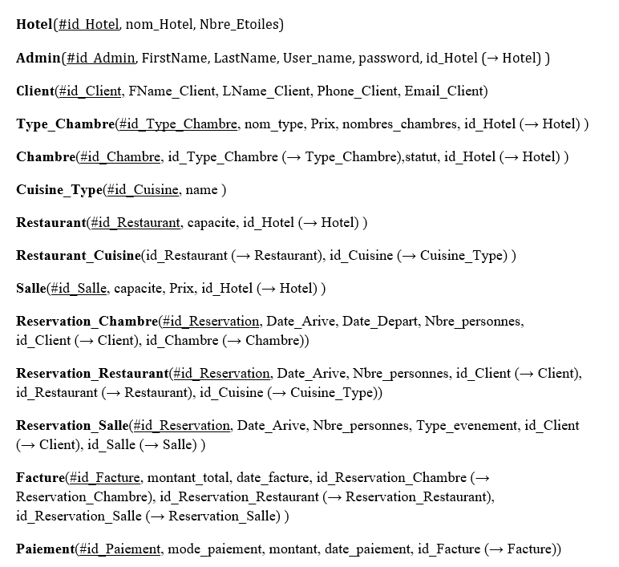

### **The Diagram of MCT**

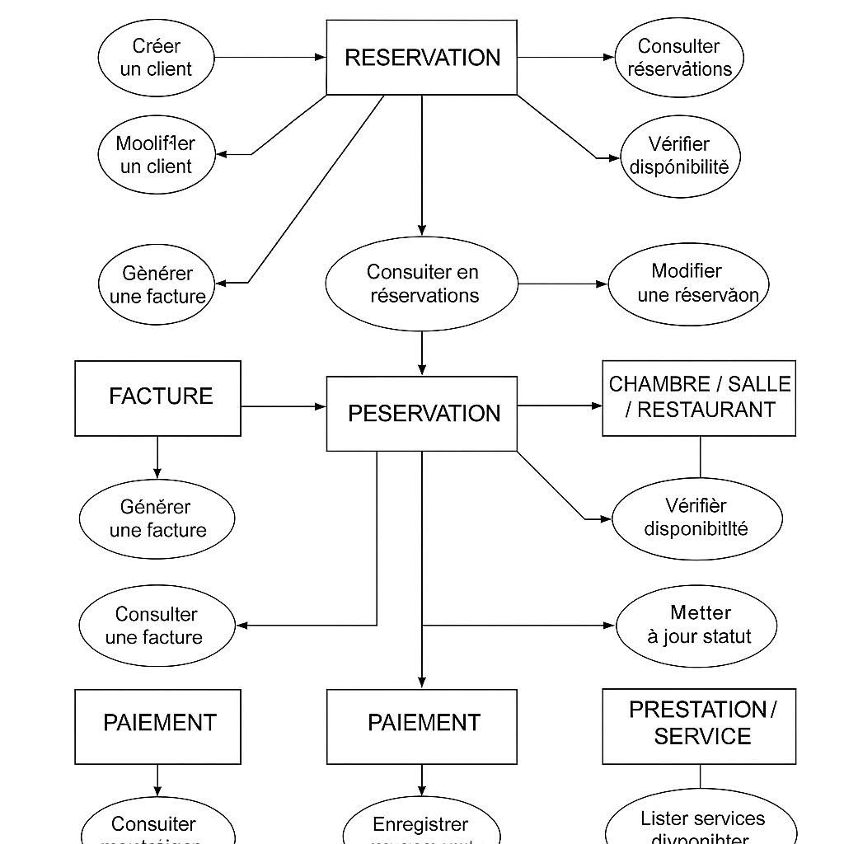

**Figure 2 : The MCT diagram of our system**

# **System Development**

System development involves the steps needed to build and implement the hotel booking system. It follows a structured approach to meet business needs and ensure a smooth user experience. In the first phase, requirements were gathered from hotel staff and managers to understand the current process and identify improvements.

## **.General System Architecture**

The hotel booking system is built using a three-layer architecture: the Presentation Layer, the Application Layer, and the Data Layer. Each part plays a specific role and works together to ensure a smooth and reliable user experience.

The Presentation Layer is the user interface developed with HTML, CSS, and JavaScript. It allows users to view hotel details, check room availability, and make reservations easily.  
The Application Layer is the backend of the system, developed using PHP and JavaScript. It handles user requests, processes bookings, and connects the frontend to the database. JavaScript is also used here to manage dynamic actions and enhance interactivity.

The Data Layer uses a MySQL database to store customer data, room information, and reservations. It ensures that all data is organized, secure, and up to date. This architecture follows a client-server model, making the system scalable, efficient, and easy to maintain or improve in the future.

## **.System Design**

Based on the requirements, a conceptual data model (MCD) was created to map out the core entities and their relationships. This was followed by designing the database schema, user interface mockups, and defining workflows such as user authentication, booking creation, and notification handling.

### **4.2.1. Programming Languages and Technologies**

|  |  |  |  |
| --- | --- | --- | --- |
| * HTML (Hypertext Markup Language):   Used for structuring the web pages.  HTML is the backbone of any web application and ensures the proper layout of content. | Logo, Html, Html5, png | PNGWing | | |
| * CSS (Cascading Style Sheets):   Employed for styling the web pages.  CSS was crucial for making the website  visually appealing and ensuring a good user experience. | | | CSS | web.dev |

|  |  |
| --- | --- |
| - PHP (Hypertext Preprocessor):  A server-side scripting language  used for building dynamic content.  PHP enabled the interaction with  the database and the execution of server-side logic. | PHP — Wikipédia |

|  |  |
| --- | --- |
| * JavaScript:   A programming language that allows you to create dynamically updated content, control multimedia content animate images, and anything else you can think of. | What Is JavaScript Used For? |

|  |  |
| --- | --- |
| SQL (Structured Query Language) is used to create, manage, and manipulate databases. It allows users to insert, update, delete, and query data efficiently. | Microsoft SQL | Nexus Tech |

### **4.2.2. Database Management**

|  |  |
| --- | --- |
| * MySQL**:**   A relational database management system used for storing and managing event data. MySQL is known for its reliability and efficiency in handling large datasets.   * phpMyAdmin:   A free and open-source administration tool for MySQL. phpMyAdmin was used for database management tasks, such as creating tables, running queries, and managing user permissions. |  |

### **4.2.3. Development Environment**

- VS Code (Visual Studio Code): A lightweight but powerful source code editor that supports a wide range of programming languages and tools.

Extensions for PHP, HTML, and CSS were used to enhance development efficiency.

|  |
| --- |
|  |

### **XAMPP - Télécharger4.2.4. Testing and Debugging Tools**

|  |
| --- |
| - XAMPP: An open-source cross-platform web server solution stack package that includes Apache server, MySQL, PHP, and Perl. XAMPP was used for local development and testing of the website. |

|  |  |  |
| --- | --- | --- |
| GitHub : A platform for hosting and reviewing code, managing projects, and collaborating on software development. The project repository was maintained on GitHub for easy access and collaboration. |  | Qu'est-ce que GitHub et comment fonctionne-t-il ? - Développement  Programmation - Dessein-Tech |

**Version Control :**

## **Implementation**

During this stage, the system modules were implemented incrementally:

* User login and role management
* Room listing and booking interface
* Admin dashboard to manage rooms, prices, and availability
* Service selection and booking integration

**Hardware**

The development of our website is carried out via this laptop having the following characteristics:

|  |  |
| --- | --- |
| Model | msi GV62 8RD |
| Processor | Intel(R) Core(TM) i7-8750H CPU @ 2.20GHz 2.20 GHz |
| RAM | 16 GO |
| Operating system | Windows 10 pro |

# **General Conclusion**

This report presented the design and development of a hotel booking management system aimed at simplifying reservations and improving hotel service management. The system provides a user-friendly interface that allows customers to book rooms and request additional services, while enabling hotel staff to manage room availability and updates more efficiently.

During the development process, we faced several challenges, including limited time, lack of experience in database handling, and working with multiple programming languages. These difficulties impacted our progress at times but were gradually overcome through research, testing, and collaboration.

Despite its functionality, the system still has some limitations. It lacks advanced features such as real-time booking status, integrated payment options, and admin dashboards. In addition, minor bugs and inconsistencies were observed, particularly with input validation and mobile compatibility. These limitations highlight areas for improvement in future versions.

## **Future Perspectives**

Looking ahead**,** we plan to enhance the system by adding new features such as an admin panel for managing content (including images and information), booking status tracking, customer feedback sections, and promotional offers. We also aim to improve the system’s performance, strengthen security, and optimize mobile responsiveness to provide a more complete, reliable, and professional platform for both users and hotel administrators.

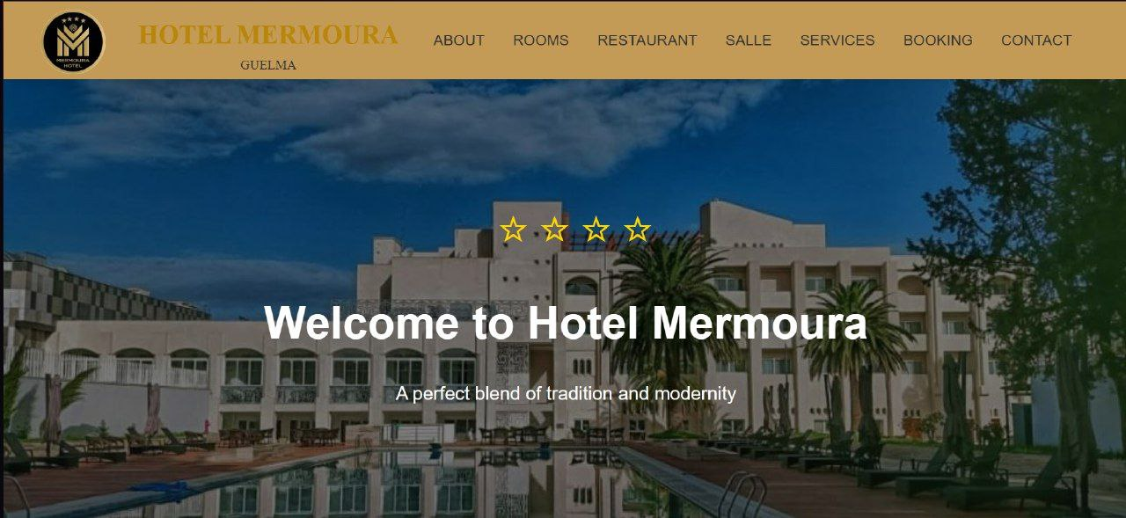**Below are a few screenshots of the website we developed:**

